Process Flow Documentation: Optimaizer Grader – AI-Powered Assessment Platform
1.0 System Overview & Core Functionality
Optimaizer Grader transforms assessment workflows by combining educator expertise with AI efficiency. The system learns from instructor feedback to apply consistent, rubric-based grading while generating personalized, actionable feedback for students.
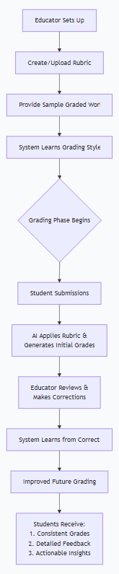
Diagram 1: Core System Flow – Showing the continuous learning loop between educators and AI
2.0 Complete Assessment Workflow
The end-to-end process from assignment creation to student feedback follows a structured yet adaptable pathway.
Diagram 2: Complete Grading Workflow – Illustrating the flexible review options for educators
3.0 Rubric Learning & Application Process
The system learns educator preferences through rubric analysis and example-based training.
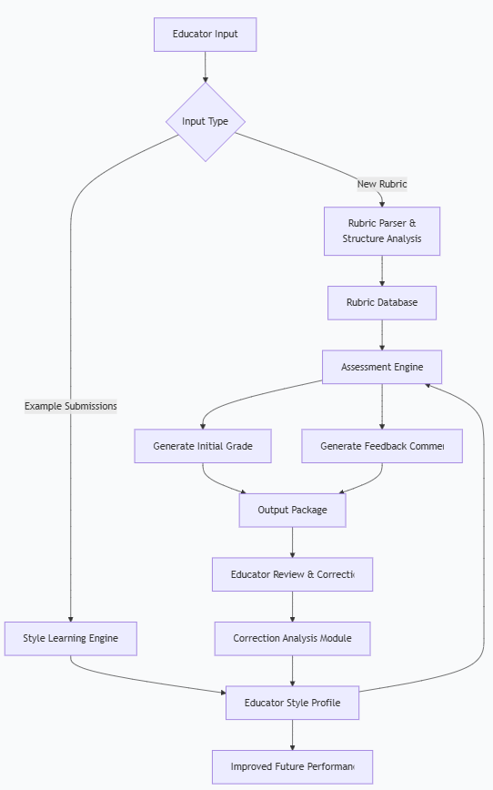
Diagram 3: Rubric Learning System – Showing how the system learns from both rubrics and example grading
4.0 Student Submission Processing
Each student submission undergoes consistent, multi-step evaluation against the established rubric.
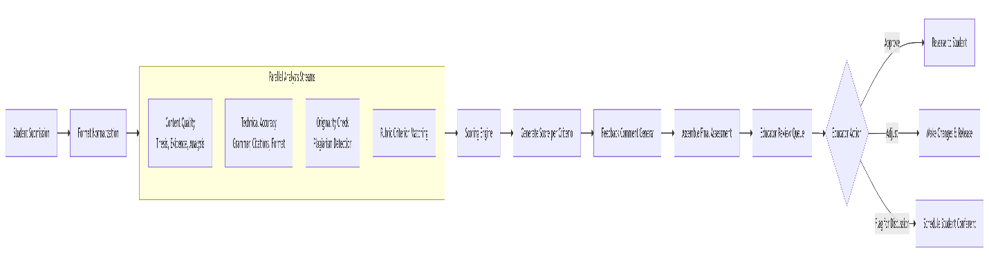

Diagram 4: Submission Processing Flow – Showing parallel analysis pathways for comprehensive assessment
5.0 Feedback Generation System
The system creates personalized feedback that explains grades and suggests improvements.
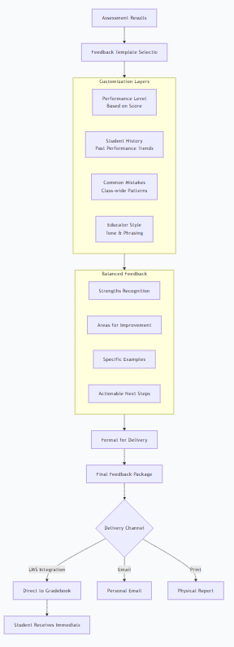
Diagram 5: Feedback Generation Process – Illustrating how personalized, constructive feedback is created
6.0 Educator Interface & Control
Educators maintain complete control through an intuitive dashboard with multiple oversight options.
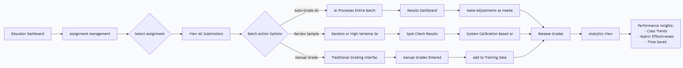
Diagram 6: Educator Control Flow – Showing the flexible grading options available to educators
7.0 Learning & Improvement Cycle
The system continuously improves through educator corrections and performance analysis.
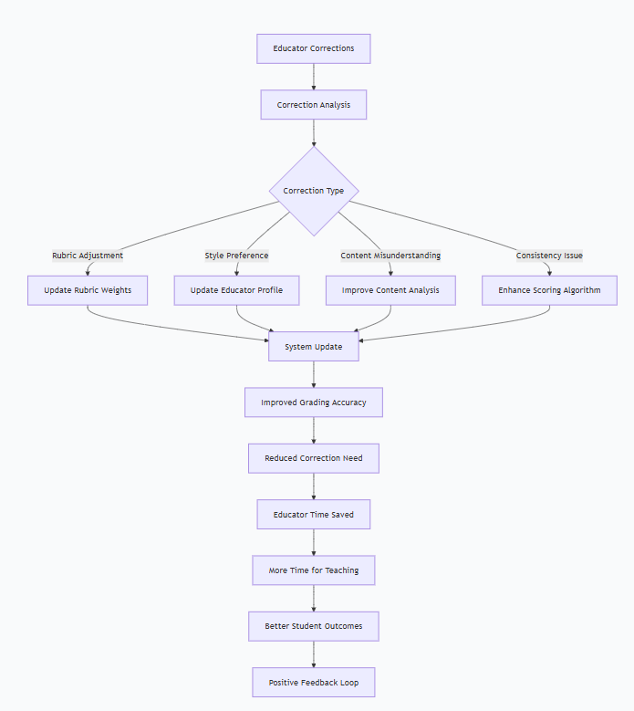
Diagram 7: Continuous Improvement Cycle – Illustrating how corrections lead to system enhancement
8.0 Student Experience Flow
Students experience a transparent, supportive assessment process with clear pathways for improvement.
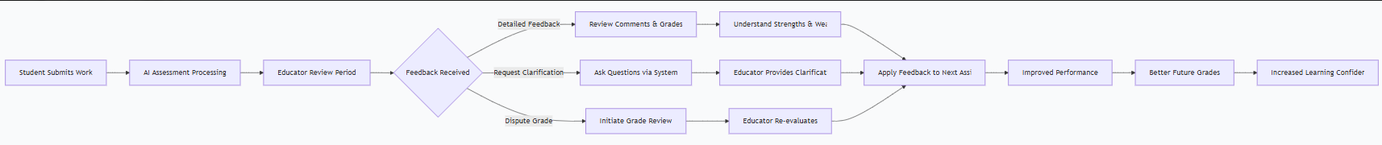
Diagram 8: Student Learning Journey – Showing how students engage with and benefit from the system
9.0 Integration with Learning Ecosystems
Optimaizer Grader connects seamlessly with existing educational technology infrastructure.
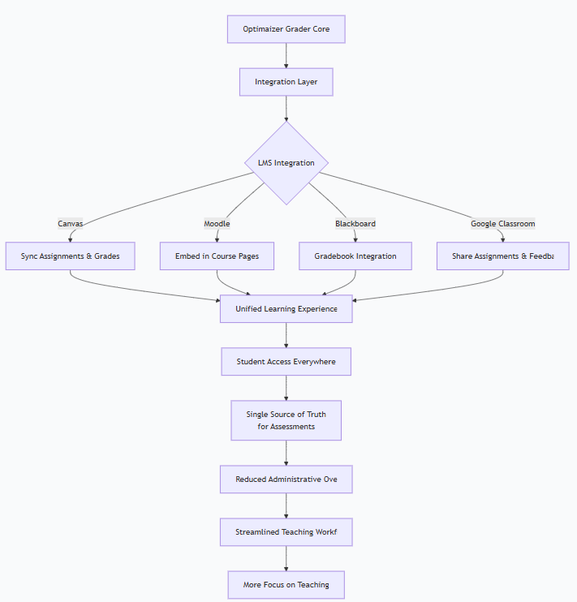
Diagram 9: System Integration Flow – Showing how the platform connects with common learning management systems
10.0 Quality Assurance & Fairness
Multiple checks ensure grading consistency and fairness across all student work.
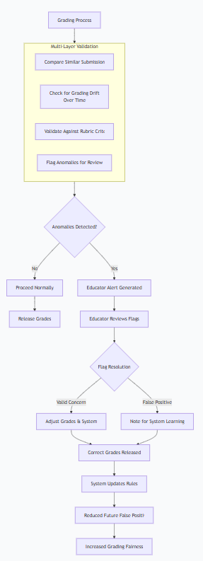
Diagram 10: Quality Assurance Process – Illustrating how the system maintains consistency and fairness

System Benefits Summary
For Educators | For Students | For Institutions
Reduces grading time by 60-80% | Receives faster feedback | Improves assessment consistency
Maintains grading style and standards | Gets detailed, actionable comments | Reduces grading workload costs
Identifies class-wide learning gaps | Understands grade rationale | Provides learning analytics
Scales to large classes easily | Tracks improvement over time | Supports accreditation standards
Key Performance Metrics
Metric | Target | Measurement
Grading Time Reduction | 70% | Time comparison studies
Grading Consistency | 95% agreement | Educator correction rate
Student Satisfaction | 4.5/5 | Feedback surveys
System Accuracy | 90% initial accuracy | Educator approval rate

Conclusion
Optimaizer Grader creates a harmonious partnership between educators and AI, where technology handles the repetitive aspects of assessment while educators maintain control over standards and style. The system's learning capability ensures it becomes more aligned with each educator's approach over time, creating a personalized grading assistant that scales to any class size while maintaining the human touch essential for effective education.
The streamlined processes reduce administrative burden while enhancing the quality and timeliness of student feedback, ultimately creating better learning outcomes through more consistent assessment and clearer guidance for improvement.

